GT2

Garbage Truck Tracker

Version 1.0

J.K.M.M.Thilakarathne   
130597L

Revision History

|  |  |  |  |
| --- | --- | --- | --- |
| Date | Version | Description | Author |
| 10/April/2016 | 1.0 | First phase | MSquad |
|  |  |  |  |
|  |  |  |  |
|  |  |  |  |

Table of Contents

1. Introduction 5

1.1 Purpose 5

1.2 Scope 5

1.3 Definitions, Acronyms, and Abbreviations 5

1.4 References 6

1.5 Overview 6

2. Overall Description 6

2.1 Product perspective 6

2.2 Product functions 6

2.3 User characteristics 7

2.4 Constrains 7

2.5 Assumptions and dependencies 7

3. Specific Requirements 8

3.1 Functionality 8

3.1.1 System Administrator 8

3.1.1.1 Use Case: System Administrator updates the system. 8

3.1.1.1.5 Normal Path: System administrator adds a new route 10

3.1.1.2 Use Case: System administrator observe truck fleet on the map 11

3.1.1.2.1 Normal Path: System administrator views entire fleet 11

3.1.1.2.2 Normal Path: System administrator views trucks by a specific route 12

3.1.1.3 Use Case: System Administrator manages feedbacks 12

3.1.1.3.1 Normal Path: System administrator views feedback 12

3.1.1.3.2 Normal Path: System administrator responds to a feedback 13

3.1.1.4 Use Case: System Administrator manages users 13

3.1.1.4.1 Normal Path: System administrator Register an townsman in the system 13

3.1.1.4.2 Normal Path: System administrator updates townsman’s account details 14

3.1.1.4.3 Normal Path: System administrator Register an System administrator in the system 14

3.1.1.4.4 Normal Path: System administrator updates own account details 14

3.1.1.4.5 Normal Path: System administrator deletes an user account 15

3.1.1.5 Use Case: GT2 sends notifications 15

3.1.2 Townspeople 15

3.1.2.1 Use Case: Townsman observe truck fleet on the map 15

3.1.2.1.1 Normal Path: View trucks real-time on registered route via web application 16

3.1.2.1.2 Normal Path: View trucks real-time on registered route via mobile application 16

3.1.2.2 Use Case: Townsman setups his notification profile 16

3.1.2.2.1 Normal Path: Townsman setups his notification profile to track the trucks via web application or mobile application. 16

3.1.2.3 Use Case: Townsman signs up in the GT2 system 17

3.1.2.3.1 Normal Path: Townsman signs up using web or mobile application 17

3.1.2.4 Use Case: Townsman manages his account 17

3.1.2.4.1 Normal Path: Townsman updates his account 17

3.1.2.5 Use Case: Townsman leaves feedback 18

3.1.2.5.1 Normal Path: Townsman leaves a feedback 18

3.2 Usability 18

3.3 Reliability 19

3.3.1 Availability 19

3.3.2 Mean Time between Failures (MTBF) 19

3.3.3 Mean Time to Repair (MTTR) 19

3.3.4 Accuracy 19

3.4 Performance 19

3.4.1 Capacity 20

3.4.2 Response Time 20

3.4.3 Throughput 20

3.4.4 Resource utilization 20

3.5 Security 20

3.6 Supportability 20

3.7 Design Constraints 20

3.7.1 Shall use full stack framework – Meteor 20

3.7.2 Shall use hybrid platform 20

3.7.3 Shall use MongoDB as database system. 20

3.7.4 IDE 21

3.7.5 Development process 21

3.7.6 Limit Module Size 21

3.8 On-line User Documentation and Help System Requirements 21

3.9 Purchased Components 21

3.10 Interfaces 21

3.10.1 User Interfaces 21

3.10.2 Hardware Interfaces 22

3.10.3 Software Interfaces 22

3.10.4 Communications Interfaces 23

3.11 Database Requirements 23

3.12 Licensing, Legal, Copyright, and Other Notices 23

3.13 Applicable Standards 23

3.13.1 Android application 23

3.13.2 IOS application 23

# Introduction

This section introduces the system requirements specification (SRS) for the Garbage Truck Tracker (GT2) system to its readers.

This document describes the functional and non-functional requirements to provide a complete and comprehensive description of the requirements for the “Garbage Truck Tracker” software system.

## Purpose

The purpose of this document is to define the requirements gathering process used to elicit requirements from the product stakeholders, to define the overall vision and goals of this new product, and to list those functional and non-functional requirements that are essential to the success of this product. This document is intended for both the stakeholders and the developers of the system.

## Scope

This system is to make the garbage collecting system of an Urban Council, Municipal council and Town Council more efficient. Using this system, people can be aware of the garbage collecting trucks of their area and properly deliver garbage without any inconveniences. Finally, people can make their neighbourhood a clean and a pleasant.

System administrator will get a web based user interface to update the system and observe the truck fleet. The townspeople will get up to three user interfaces. A website, hybrid mobile application and a text messaging service.

## Definitions, Acronyms, and Abbreviations

|  |  |
| --- | --- |
| **Acronym, abbreviation** | **Definition** |
| GT2 | Garbage Truck Tracker |
| Hybrid mobile application | A mobile application that combines elements of both native and Web applications |
| Townspeople | The people who live in a town |
| Townsman | A person who lives in a town |
| SMS | Short Message Service |
| Real-time | Real-time or real time is a term often used to distinguish reporting, depicting, or reacting to events at the same rate and sometimes at the same time as they unfold |
| Truck Fleet | All the trucks |
| PC | Personal Computer |
| Info Window | Google maps information window popups when you click a map marker |
| route | The path which a truck will travel |
| PS = DC | Pradeshiya Saba , Divisional Council |
| MC | municipal council |
| UC | urban council |

## References

|  |  |
| --- | --- |
| [1] | “Galaxy,” [Online]. Available: https://www.meteor.com/galaxy/. |
| [2] | “Mongo Lab,” [Online]. Available: https://mlab.com/. |
| [3] | “Developer Policy Center,” [Online]. Available: https://play.google.com/about/developer-content-policy.html?rd=1. |
| [4] | “Brand Guidelines,” [Online]. Available: http://developer.android.com/distribute/tools/promote/brand.html. |
| [5] | “Core App Quality,” [Online]. Available: http://developer.android.com/distribute/essentials/quality/core.html. |
| [6] | “Tablet App Quality,” [Online]. Available: http://developer.android.com/distribute/essentials/quality/tablets.html. |
| [7] | “Google for Education Guidelines,” [Online]. Available: https://developers.google.com/edu/guidelines. |
| [8] | “Content ratings for apps & games,” [Online]. Available: https://support.google.com/googleplay/android-developer/answer/188189. |
| [9] | “Supported locations for distribution to Google Play users,” [Online]. Available: https://support.google.com/googleplay/android-developer/table/3541286?rd=1. |
| [10] | “APK Expansion Files,” [Online]. Available: http://developer.android.com/google/play/expansion-files.html. |
| [11] | “Supporting Multiple Screens,” [Online]. Available: http://developer.android.com/guide/practices/screens_support.html. |
| [12] | “Dashboards,” [Online]. Available: http://developer.android.com/about/dashboards/index.html. |
| [13] | “App Store Review Guidelines,” [Online]. Available: https://developer.apple.com/app-store/review/guidelines/. |

## Overview

The rest of this specification is organized in the following manner.

***Chapter 2: -*** the Overall Description section, of this document gives an overview of the functionality of the product. It describes the informal requirements and is used to establish a context for the technical requirements specification in the next chapter.

***Chapter 3: -*** Specific Requirements section, of this document is written primarily for the developers and describes in technical terms the details of the functionality of the product.

Both sections of the document describe the same software product in its entirety, but are intended for different audiences and thus use different language.

# Overall Description

This section provides a high level description of the Garbage Truck Tracker (GT2) system.

## Product perspective

The system includes a web application, hybrid mobile application and a text messaging service for mobile phones.

The web interface for system administrator will be used to update the details of garbage collecting service like time schedule and routes. The administrator can observe the track fleet real-time and get townspeople’s’ feedbacks through the system.

The townspeople can retrieve information regarding garbage trucks through web application, hybrid mobile application or SMS service. They can also give feedbacks for the garbage collecting service daily.

## Product functions

**System administrator can,**

* Updates and manages the system via web interface.
  + Add a new route that trucks will collect garbage.
  + Update the routes
* Observe the truck fleet on a real-time map via web interface.
* Manage feedbacks from townspeople.
  + View and responds the feedbacks from townspeople.
* Manage users

**Townspeople can,**

* Receive notifications about garbage trucks via mobile application
  + User can get any number of notifications before* the truck comes.
* Receive text messages about garbage trucks via mobile phone
  + User can get limited amount of notifications before* the truck comes.
* Observe garbage trucks on real-time map via mobile application or mobile application.
  + User can view available garbage trucks currently traveling with the routes.
* Give feedbacks on garbage collecting service.
  + A user can give any number of feedbacks on any day for any truck.

*user defined time (<24 hours)

## User characteristics

There are two types of user for this system.

* System Administrator – from the PS, MC or UC
* Townspeople – The people who receive the service of garbage collecting trucks

System administrator will get a web based user interface to update the system manage feedbacks and observe the truck fleet. The townspeople will get up to three user interfaces. A website, hybrid mobile application and a text messaging service.

## Constrains

* Internet connection for the hybrid mobile application is a must. So the developer should take strategic design technologies to comply the user to turn his or her mobile internet connection on.
* The whole system depends on the location trackers planted on the trucks. So it is crucial that they are working properly. If not, the developer must take precautions to protect the end users from fault information.
* SMS notification service will charge the user. So the developer should implement the functionalities while controlling the charges in a sustainable limit. (Users will be charged according to the number of messages he or she receives according to Dialog Ideamart SMS service package)
* As the users of this system will be mostly house wives a proper guidance to use the system is a must to get the most out of the system.

## Assumptions and dependencies

* The system is developed from the Hybrid mobile framework - Meteor. So the support for mobile devices’ operating systems will be limited as below
  + Android – minimum supported version –
  + IOS – minimum supported version –
* To use the hybrid application user needs a smart phone with location service turned on.
* To use the SMS notification feature, user must be a subscriber of Dialog mobile service.
* To get the perfect user experience out of the hybrid mobile application, the mobile phone should have enough hardware resources.
* To experience the perfect functionality of the system, users should not turn off notifications for the hybrid mobile application. (since notification service is the main useful function of the system)
* The responsiveness of the whole system depends on the location data collecting real-time rom garbage trucks. So the location tracking devices planted on those trucks should work fine all the time.
* To receive notifications and updates (routes, time schedule) the hybrid mobile application user must be connected to internet.

# Specific Requirements

## Functionality

### System Administrator

#### Use Case: System Administrator updates the system.

**Use Case Requirement**

The GT2 shall enable system administrator to interact with system as follow:

* Register a new driver
* Update driver details
* Register a new truck
* Update truck details
* Register a new route
* Update a route

**Use Case Paths**

* Normal
  + Register a new driver
  + Update driver
  + Register a new truck
  + Update truck
  + Register a new route
  + Update a route
* Exceptional
  + None
    - * 1. **Normal Path: System administrator registers a new truck**

**Preconditions**

* The GT2 has identified and authenticated the System Administrator.
* The truck which is going to register should be registered to the council

**Interactions**

1. System Administrator sends a register new truck request to the GT2
2. The GT2 shall respond by requesting the following information from the system administrator:
   1. Truck license number
   2. Truck model
   3. Truck registered date (to the council)
   4. A submit button to register the truck
3. System Admin fill the necessary details and submit the form.
4. The GT2 shall respond by displaying the following information to the System Admin:
   1. The “truck registered successfully” message
   2. Truck license number
   3. Truck model
   4. Truck registered date (council)
   5. Truck registered date (system)

**Post conditions**

* The new truck details are stored in the database.
  + - * 1. **Normal Path: System administrator updates a truck**

**Preconditions**

* The GT2 has identified and authenticated the System Administrator.
* The truck which is going to update should be existed in the system.

**Interactions**

1. System Administrator sends a update truck request with a selected truck to the GT2
2. The GT2 shall display the following information on the browser of the System Administrator’s PC:
   1. Truck license number
   2. Truck model
   3. Truck registered date (to the council)
   4. Truck registered date (in the system) – cannot edit
3. System Admin change the necessary details and submit the form.
4. The GT2 shall respond by displaying the following information to the System Admin:
   1. The “truck details updated successfully” message
   2. Truck license number
   3. Truck model
   4. Truck registered date (council)
   5. Truck registered date (system)

**Post conditions**

* The truck details are updated in the database.
  + - * 1. **Normal Path: System administrator registers a new driver**

**Preconditions**

* The GT2 has identified and authenticated the System Administrator.
* A driver must exists and an employee of the council.

**Interactions**

1. System Administrator sends a register new driver request to the GT2
2. The GT2 shall respond by requesting the following information from the system administrator:
   1. Driver’s Name
   2. Employee number
   3. NIC number
   4. Driving license number
   5. Mobile phone number
3. System Admin fill the necessary details and submit the form.
4. The GT2 shall respond by displaying the following information to the System Admin:
   1. The “driver registered successfully” message
   2. Driver’s Name
   3. Employee number
   4. NIC number
   5. Driving license number
   6. Mobile phone number

**Post conditions**

* The new driver details are stored in the database.
  + - * 1. **Normal Path: System administrator updates driver details**

**Preconditions**

* The GT2 has identified and authenticated the System Administrator.
* The driver who is going to be updated should be existed in the system.

**Interactions**

1. System Administrator sends a update driver request with a selected driver to the GT2
2. The GT2 shall display the following information on the browser of the System Administrator’s PC:
   1. Driver’s Name
   2. Employee number
   3. NIC number
   4. Driving license number
   5. Mobile phone number
   6. Driver registered date (in the system) – cannot edit
3. System Admin change the necessary details and submit the form.
4. The GT2 shall respond by displaying the following information to the System Admin:
   1. The “driver updated successfully” message
   2. Driver’s Name
   3. Employee number
   4. NIC number
   5. Driving license number
   6. Mobile phone number
   7. Driver registered date (in the system)

**Post conditions**

* The driver details are updated in the database.

##### Normal Path: System administrator adds a new route

Preconditions

* The GT2 has identified and authenticated the System Administrator.
* The new route is validated practically by the council.
* There exists an available truck
* There exists an available driver

**Interactions**

1. System Administrator sends a add new route request to the GT2
2. The GT2 shall display the following information on the browser of the System Administrator’s PC:
   1. The map which the local authority is centered (Google map)
   2. Tools to draw the route on map
   3. Input field to enter start time
   4. Check boxes to select the garbage type collecting on relevant day of the week
   5. A drop down box with available trucks
   6. A drop down box with available drivers
   7. A submit button to register the route
3. System Admin fill the necessary details and submit the form.
4. The GT2 shall respond by displaying the following information to the System Admin:
   1. The “route registered successfully” message
   2. The route drawn on a map
   3. Starting time and estimated finishing time
   4. Route active days with collecting garbage type
   5. The truck details assigned to the route
   6. The driver details assigned to the truck

**Post conditions**

* The GT2 stores the route on the database with a unique route number automatically generated by the GT2.
* After 10 minutes (incase if the system administrator needs to do some quick modifications to the newly registered route) a notification saying that “a new route has been added to the system” with the new route information is sent to the mobile clients (through internet connection).
* The truck driver gets a SMS with route details.
  + - * 1. **Normal Path: System administrator updates a route**

**Preconditions**

* The GT2 has identified and authenticated the System Administrator.
* There must be at least one existing route registered.
* The modifying route must not be active at the moment.
* There exists an available truck
* There exists an available driver

**Interactions**

1. System Administrator sends an “update route” request to the GT2
2. The GT2 shall display registered routes on the browser of the System Administrator’s PC
3. System Administrator select a route and request to edit it.
4. The GT2 shall display the following information on the browser of the System Administrator’s PC:
   1. The map with the current route
   2. Tools to modify the route on map
   3. Input field to modify start time
   4. Check boxes to select the garbage type collecting on relevant day of the week
   5. A drop down box with available trucks
   6. A drop down box with available drivers
   7. A submit button to save the changes made to the route
5. System Admin change the necessary fields and submit the form.
6. The GT2 shall respond by displaying the following information to the System Admin:
   1. The “route updated successfully” message
   2. The route drawn on a map
   3. Starting time and estimated finishing time
   4. Route active days with collecting garbage type
   5. The truck details assigned to the route
   6. The driver details assigned to the truck

**Post conditions**

* The GT2 modifies the route on the database
* After 10 minutes (incase if the system administrator needs to do some quick modifications to the route) a notification saying that “a route has been added to the system” with the new route information is sent to the mobile clients (through internet connection).
* The truck drivers gets a SMS with route details. (if a different driver is selected)

#### Use Case: System administrator observe truck fleet on the map

**Use Case Requirement**

The GT2 shall enable system administrator to observe the truck fleet real-time on a map

**Use Case Paths**

* Normal
  + View the entire fleet
  + View by a specific route
* Exceptional

##### Normal Path: System administrator views entire fleet

**Preconditions**

* The GT2 has identified and authenticated the System Administrator.

**Interactions**

1. System Administrator sends an request to view the entire truck fleet to the GT2
2. The GT2 shall display all the trucks and active routes on the browser of the System Administrator’s PC. The trucks on duty and trucks which are currently not on duty shall be indicated with different markers.
3. System administrator click on a truck or a route
4. GT2 shall display an info window on the map with following details:
   1. if a truck is selected
      1. whether the truck is on duty or not
      2. truck licence number
      3. driver’s name and mobile phone number
   2. if a route is selected
      1. route active time
      2. truck details

**Post conditions**

* None

##### Normal Path: System administrator views trucks by a specific route

**Preconditions**

* The GT2 has identified and authenticated the System Administrator.

**Interactions**

1. System Administrator sends a request to view trucks by specific route to the GT2 with a selected route.
2. The GT2 shall display the requested route on the browser of the System Administrator’s PC.
3. System administrator click on a truck or a route
4. GT2 shall display an info window on the map with following details:
   1. if a truck is selected
      1. whether the truck is on duty or not
      2. truck licence number
      3. driver’s name and mobile phone number
   2. if a route is selected
      1. route active time
      2. truck details

**Post conditions**

* None

#### Use Case: System Administrator manages feedbacks

**Use Case Requirement**

The GT2 shall enable system administrator to manage townspeople’s feedbacks as follow **:**

* view feedbacks
* respond the feedbacks

**Use Case Paths**

* Normal
  + View feedback
  + Respond the feedback
* Exceptional
  + None

##### Normal Path: System administrator views feedback

**Preconditions**

* Townspeople has given some feedback

**Interactions**

1. GT2 shall respond by displaying following information on the system administrator’s browser
   1. Notification window
   2. Increasing the notification count of the notification icon
2. System administrator clicks on the notification window or the notification icon
3. GT2 shows previews of all new notifications
4. System administrator select a notification(about feedback) to view
5. GT2  display the feedback with following details
   1. Feedback title
   2. Feedback
   3. Date

If the feedback is about the service of a truck,

* 1. Route
  2. Location – name (with link to the map)
  3. Truck details
  4. Driver details

**Post conditions**

* The notification count decreases.

##### Normal Path: System administrator responds to a feedback

**Preconditions**

* Townspeople has given some feedback
* System administrator has just opened a notification about a feedback

**Interactions**

1. GT2 display the feedback with following details and an input box to reply to the feedback.
   1. Feedback title
   2. Feedback
   3. Date

If the feedback is about the service of a truck,

* 1. Route
  2. Location – name (with link to the map)
  3. Truck details
  4. Driver details

1. System administrator reads and reply the feedback.

**Post conditions**

* The notification count decreases.
* A notification is sent to the user who has sent the feedback early.

#### Use Case: System Administrator manages users

**Use Case Requirement**

The GT2 shall enable system administrator to manage accounts**.**

**Use Case Paths**

* Normal
  + Register an Townsman in the system
  + Update Townsman account details
  + Register an System administrator in the system
  + Update own account details
  + Delete an user account
* Exceptional
  + None

##### Normal Path: System administrator Register an townsman in the system

**Preconditions**

* The GT2 has identified and authenticated the System Administrator.

**Interactions**

1. System administrator sends a normal user registration request to the GT2
2. The GT2 shall respond by requesting the following information:
   1. User’s name
   2. NIC number
   3. Location - can be selected from a map
   4. Mobile phone number
3. System administrator supplies the necessary details and submit the form.
4. The GT2 shall respond by displaying the following information:
   1. The “User registered successfully” message
   2. Name
   3. NIC number
   4. Location on a map
   5. Mobile phone number

**Post conditions**

* The new user details are stored in the database.

##### Normal Path: System administrator updates townsman’s account details

**Preconditions**

* The GT2 has identified and authenticated the System Administrator.
* The townsman’s user account is selected to update.

**Interactions**

1. System administrator sends a update account request to the GT2 with the selected townsman account
2. The GT2 shall respond by requesting the following information:

(Existing details will appear in the input fields)

* 1. Name
  2. NIC number
  3. Location - can be selected from a map
  4. Mobile phone number

1. Townsman supplies the necessary details and submit the form.
2. The GT2 shall respond by displaying the following information:
   1. The “signed up successfully” message
   2. Name
   3. NIC number
   4. Location on a map

**Post conditions**

* The user details are updated in the database.

##### Normal Path: System administrator Register an System administrator in the system

**Preconditions**

* The GT2 has identified and authenticated the System Administrator.

**Interactions**

1. System administrator sends a super user registration request to the GT2
2. The GT2 shall respond by requesting the following information:
   1. User’s name
   2. NIC number
   3. Email address
   4. Mobile phone number
3. System administrator supplies the necessary details and submit the form.
4. The GT2 shall respond by displaying the following information:
   1. The “User registered successfully” message
   2. Name
   3. NIC number
   4. Email address
   5. Mobile phone number

**Post conditions**

* The new user details are stored in the database.

##### Normal Path: System administrator updates own account details

**Preconditions**

* The GT2 has identified and authenticated the System Administrator.

**Interactions**

1. System administrator sends a update account request to the GT2
2. The GT2 shall respond by requesting the following information:
3. (Existing details will appear in the input fields)
   1. Name
   2. NIC number
   3. Email address
   4. Mobile phone number
4. Townsman supplies the necessary details and submit the form.
5. The GT2 shall respond by displaying the following information:
   1. The “signed up successfully” message
   2. Name
   3. NIC number
   4. Email address

**Post conditions**

* The user details are updated in the database.

##### Normal Path: System administrator deletes an user account

**Preconditions**

* The GT2 has identified and authenticated the System Administrator.
* A user account has been selected to delete

**Interactions**

1. System administrator sends a delete request to the GT2 with the selected user account
2. The GT2 shall respond by requesting confirmation:
3. System administrator confirms the delete operation

**Post conditions**

* The user is deleted from the database.

#### Use Case: GT2 sends notifications

**Use Case Requirement**

The GT2 system shall give notifications to townspeople, drivers and system administrator

**Use Case Paths**

* Normal
  + Notify system administrator about a customer feedback
  + Notify the relevant townspeople on the response to his or her feedback
  + Notify townspeople about truck schedules
  + Notify townspeople about current truck location
  + Notify townspeople about route updates
  + Notify driver on assignment to routes
* Exceptional

### Townspeople

#### Use Case: Townsman observe truck fleet on the map

**Use Case Requirement**

The GT2 shall enable townspeople to observe the truck fleet real-time on a map

**Use Case Paths**

* Normal
  + View trucks real-time on registered route via web application
  + View trucks real-time on registered route via hybrid mobile application
* Exceptional
  + None

##### Normal Path: View trucks real-time on registered route via web application

**Preconditions**

* The GT2 web application has identified and authenticated the user.

**Interactions**

1. Townsman sends an request to view the route to the GT2
2. The GT2 shall display all the trucks (if on active duty on the route) on the route with following details:
   1. Truck schedule with garbage type for the day
   2. If a truck is on the route coming at the townsman, estimated time to reach.

**Post conditions**

* None

##### Normal Path: View trucks real-time on registered route via mobile application

**Preconditions**

* The townsman has signed in to the application.

**Interactions**

1. Townsman sends an request to view the route to the GT2
2. The GT2 shall display all the trucks (if on active duty on the route) on the route with following details:
   1. Truck schedule with garbage type for the day
   2. If a truck is on the route coming at the townsman, estimated time to reach.

**Post conditions**

* None

#### Use Case: Townsman setups his notification profile

**Use Case Requirement**

The GT2 shall enable townspeople to receive notifications on trucks locations.

**Use Case Paths**

* Normal
  + Setup notification profile to track the trucks
* Exceptional
  + None

##### Normal Path: Townsman setups his notification profile to track the trucks via web application or mobile application.

**Preconditions**

* The townsman has signed in to the application.
* If he using the mobile application, the phone must be connected to the internet.

**Interactions**

1. Townsman sends a request to setup his notification profile to the GT2
2. GT2 shall respond by displaying a plus signed button to add a new notification.
3. Townsman clicks the button
4. GT2 shall respond by requesting following details:
   1. The time in advance before truck arrives that the notification should receive
   2. Which routes should track
5. Townsman fill the details
6. Can add more notifications like this
7. Townsman saves the settings

**Post conditions**

* The notification settings for the townsman is updated to the database.

#### Use Case: Townsman signs up in the GT2 system

**Use Case Requirement**

The GT2 shall enable townspeople to register in the system.

**Use Case Paths**

* Normal
  + Sign up using web or mobile application
* Exceptional
  + None

##### Normal Path: Townsman signs up using web or mobile application

**Preconditions**

* Installed the mobile application (if not from web)
* Location service must be turned on (if using a mobile application)

**Interactions**

1. Townsman sends a signup request to the GT2
2. The GT2 shall respond by requesting the following information:
   1. Name
   2. NIC number
   3. Location - can be selected from a map
   4. Mobile phone number
3. Townsman supplies the necessary details and submit the form.
4. The GT2 shall respond by displaying the following information:
   1. The “signed up successfully” message
   2. Name
   3. NIC number
   4. Location on a map

**Post conditions**

* The new user details are stored in the database.
* Townsman is requested to setup his notification profile.

#### Use Case: Townsman manages his account

**Use Case Requirement**

The GT2 shall enable townspeople to update, delete his account.

**Use Case Paths**

* Normal
  + Update account details
  + Delete account
* Exceptional
  + None

##### Normal Path: Townsman updates his account

**Preconditions**

* Signed in to the account
* Location service must be turned on (if using a mobile application)

**Interactions**

1. Townsman sends a update account request to the GT2
2. The GT2 shall respond by requesting the following information:

(Existing details will appear in the input fields)

* 1. Name
  2. NIC number
  3. Location - can be selected from a map
  4. Mobile phone number

1. Townsman supplies the necessary details and submit the form.
2. The GT2 shall respond by displaying the following information:
   1. The “signed up successfully” message
   2. Name
   3. NIC number
   4. Location on a map

**Post conditions**

* The new user details are updated in the database.

#### Use Case: Townsman leaves feedback

**Use Case Requirement**

The GT2 shall enable townspeople to leave feedbacks on the truck service**.**

**Use Case Paths**

* Normal
  + Leave feedback
* Exceptional
  + None

##### Normal Path: Townsman leaves a feedback

**Preconditions**

* Townspeople must be signed in to the system.

**Interactions**

1. Townsman request to leave a feedback from the GT2
2. The GT2 shall respond by requesting the following information:
   1. Feedback title
   2. Feedback

It shows a checkbox saying “leave feedback on a service from a specific truck”

1. Townsman check the checkbox.
2. Following inputs will appear:
   1. Route
   2. Location – with option to select from a map
   3. Truck license number
3. Townsman fills the details and submit the form.

**Post conditions**

* The feedback is saved to the database
* A notification is sent to the system administrator

## Usability

This subsection specifies the requirements associated with the ease with which the system can be used.

This is the first time that a system like this will expose to the townspeople and the councils. And among the townspeople, the usual users will be house wives. So the system must give a straightforward and a coherent user experience (UX) to the users.

* The application shall enable at least 90% of a statistically valid sample of representative novice townspeople to:
  + Sign up within 10 minutes.
  + Setup the notification profile within 8 minutes
  + Leave a feedback within 5 minutes.
* The application shall enable at least 90% of a statistically valid sample of representative experienced townspeople to:
  + Leave a feedback within 5 minutes.
  + Setup the notification profile within 4 minutes
* The application shall enable at least 95% of a statistically valid sample of representative novice system administrator to:
  + Update a route within 10 minutes.
  + Register a new driver within 10 minutes.
  + Update driver details within 8 minutes.
  + Register a new truck within 10 minutes.
  + Update truck details within 8 minutes.
  + Respond to a feedback within 10 minutes.
* The application shall enable at least 98% of a statistically valid sample of representative experienced system administrator to:
* Update a route within 5 minutes.
* Register a new driver within 5 minutes.
* Update driver details within 4 minutes.
* Register a new truck within 5 minutes.
* Update truck details within 4 minutes.
* Respond to a feedback within 5 minutes.
* Any user shall be able to freely, easily, and quickly navigate between relevant views of the application.

## Reliability

This subsection specifies the following requirements associated with the reliability.

### Availability

As the garbage collection is done in the day time, the real time tracking functionalities are no need to be available in the night. The system administrator uses the system only in the office times. So system administrator’s functions are also no need to be available in other times. The notifications are also not sent to townsman between 10:00 p.m. and 5:00 a.m. But the notification profile setup function should be available at least 99% of the time. So the maintenances of the system can be done in the night time without causing much harm to the availability of the system.

### Mean Time between Failures (MTBF)

MTBF shall exceed 12 hours.

### Mean Time to Repair (MTTR)

MTTR shall not exceed 15 minutes.

### Accuracy

Location tracking: Townsman and system administrator should be able to identify the trucks traveling on the road. So the accuracy shall be at least 5 meters.

The minimum advance time that a townsman can set up his notification profile is restricted to 5 minutes. So townsman should receive notifications about the truck location within at least 5 minutes.

## Performance

This subsection specifies the following requirements associated with the speed with which the system shall function.

### Capacity

Minimum number of objects that the system can support:

* The system shall support a minimum of 25 simultaneous trucks tracking per a council.
* The system shall support a minimum of 50 townspeople per council.
* The system shall support a minimum of 500,000 total users.

### Response Time

This is mostly a real-time mobile system. So the response time is acts a significant part.

So,

* All system responses shall occur within maximum 10 seconds.
* All system responses shall occur within average 4 seconds.

### Throughput

The system shall track 25 trucks simultaneously. .

## Security

* Every user must login first to use the system.
* The password for login must have at least 6 characters.
* The password cannot be entered incorrect more than 3 times in a row. If this happened, user need to enter the passcode sent to his or her mobile phone.
* System admin or any other user would not be able to track the location of any other townspeople.
* The feedback sent to system administrator shall be anonymous.
* The user inputs must be verified within client device before sent to the server.
* The system shall only allow unauthorized users to access the login, lost password, and registration page.

## Supportability

This system is currently in English language. But the ability to change the system to deal with additional languages like Sinhala and Tamil is anticipated.

The system is supposed to implement using “METEOR” hybrid mobile framework. It currently support only for Android and IOS mobile operating systems only. When METEOR publish an update to extend to other existing or new operating systems, the system shall be able to deploy for the new platform without altering the core architecture.

A complete documentation of the source code should be generated for maintenance prospects.

## Design Constraints

### Shall use full stack framework – Meteor

Meteor will help the developer with the full development stack from the user interface till the data store.

It means that the code is portable, and the same logic can run equally well on the server, in a web browser, and on a mobile phone.

### Shall use hybrid platform

The web application and hybrid mobile application will be generated from a one code base, which is JavaScript. And finally deployed in to Android and IOS platforms.

### Shall use MongoDB as database system.

Meteor will only run with MongoDB database. So the database system shall be MongoDB for this GT2 system.

### IDE

Developer shall use JetBrains WebStorm IDE.

### Development process

Rational Unified Process will be used for the development process.

### Limit Module Size

Shall use the optimum module size for the fewest defects (between 300 to 500 instructions per module)

## On-line User Documentation and Help System Requirements

A complete online user documentation should be provided.

A help guidance should be there to guide the first time users through the main functionality of the application.

## Purchased Components

Hence all the technologies and development tools used to develop GT2 are free, no purchases in the development phase.

But for testing and development phases, a web server and a database server should be purchased.

Web server – Galaxy (specified for Meteor web applications) [1]

Database server – MongoLab [2]

## Interfaces

### User Interfaces

The user interface for the system will be in below two types.

1. Web application user interface
2. Mobile application user interface

There will be no major differences between components in these two instead of the screen size, shape and organization. All the user interfaces are responsive and reactive.

The Google’s Material design language is requested to implement for the user interfaces in this application. So the final interfaces shall look like below.

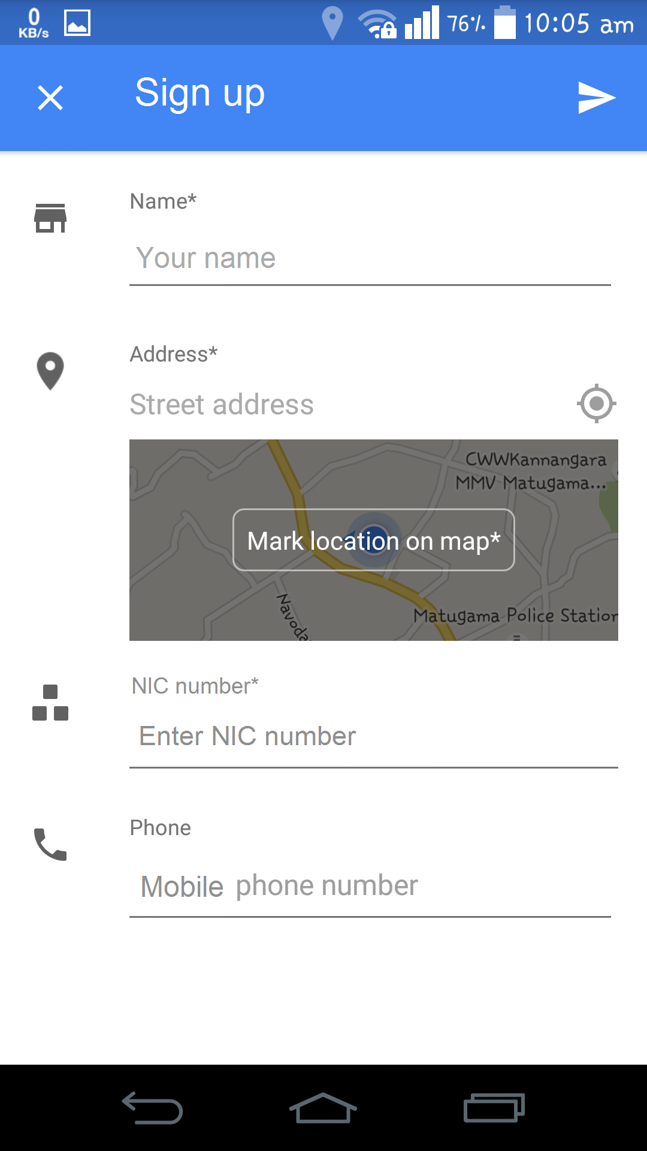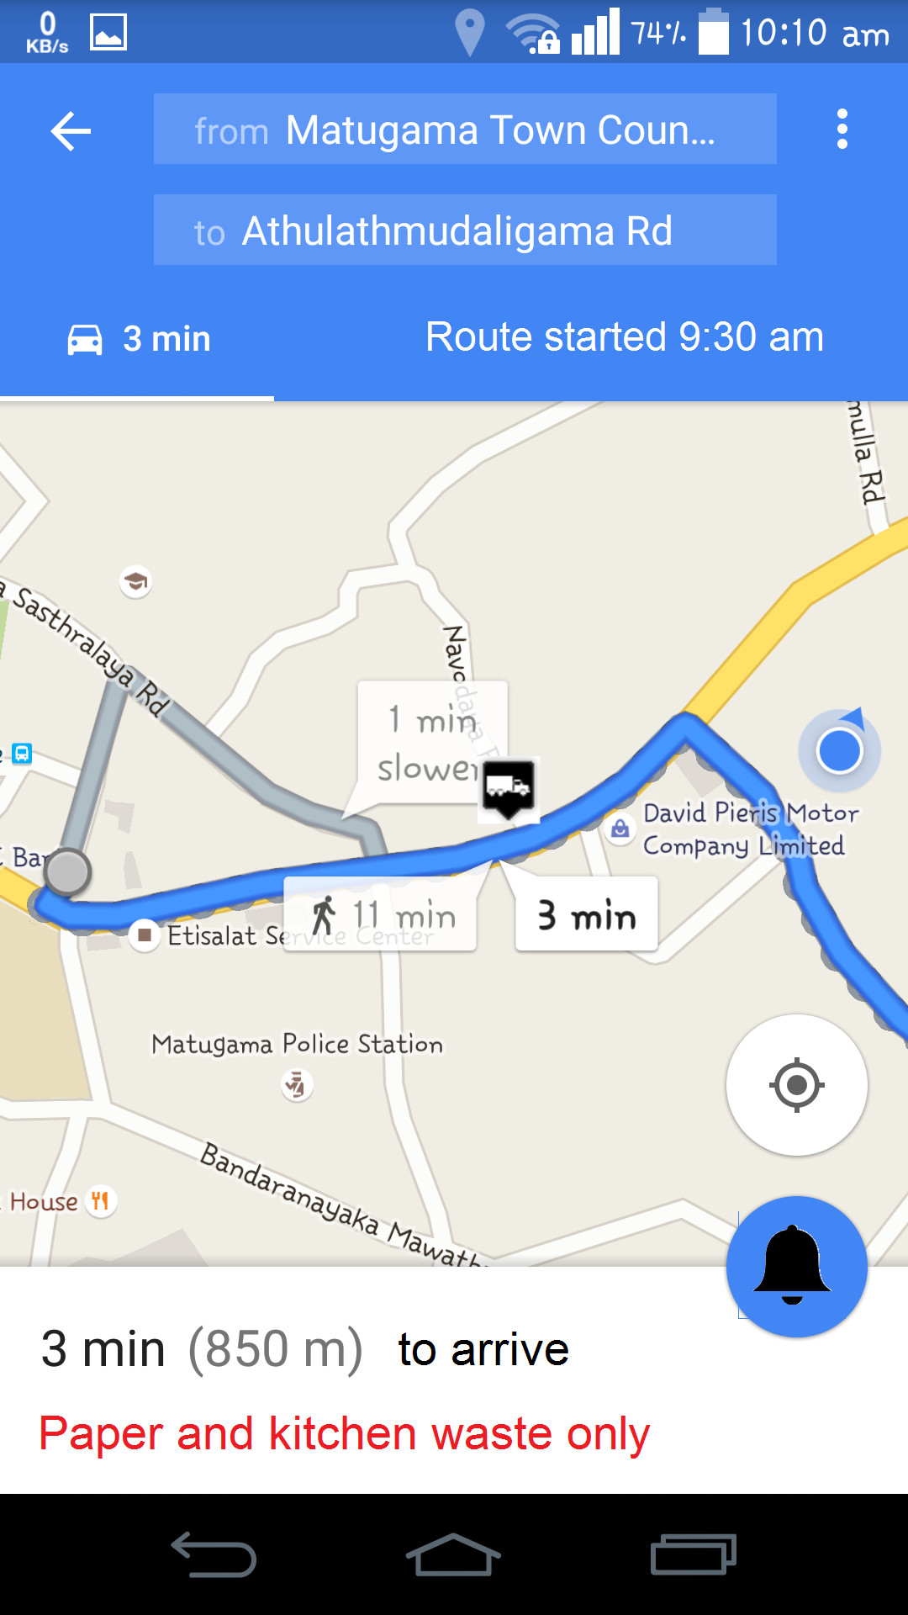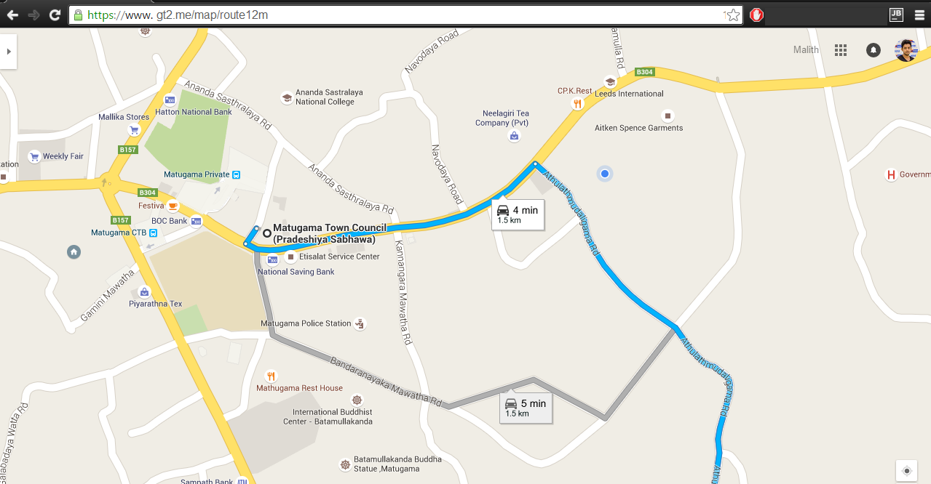

### Hardware Interfaces

This system need to access the Geolocation hardware interfaces of the mobile device.

* GPS
* Wi-Fi triangulation
* Mobile triangulation

But the GT2 is accessing these interfaces using Google map API. So no hardware dependent code will be written by the developer.

### Software Interfaces

* **Operating System**
  + The target operating systems are as follow
    - Desktop
      * Windows
      * Linux
      * Unix
    - Mobile
      * Android 4.1 and above
      * IOS
* **Web Server**
  + As Galaxy is specially designed to support Meteor applications, the web server will be Galaxy.com
* **Database**
  + - Must be MongoDB since, meteor only supports MongoDB.
* **Libraries**

*The software will be created using Meteor framework.*

### Communications Interfaces

* **Web Interface**
  + The web application will be accessed over internet.
* **Mobile Interface**
  + Mobile application will communicate with the web server. Mobile application does not have direct access to the database server, must go through the web server.
* **SMS Interface**
  + Townspeople will receive notifications through short message service.
  + User will receive passcode as a SMS as a security measure of login process.

## Database Requirements

System will take a subset of the database and copy it to the client. Instead of sending HTML code to the client, GT2 application will send the actual, raw data and let the client deal with it (data on the wire). GT2 will access that data instantaneously without having to wait for a round-trip to the server.  
To implement these functions, GT2 needs a non-rational database, which MongoDB is.

## Licensing, Legal, Copyright, and Other Notices

This system uses Google maps API. So the “Google” logo and link to terms of use must be visible on the map.

## Applicable Standards

### Android application

* Should follow Google Play Policies and Agreements [3]
* Should follow These Brand Guidelines [4]
* Should tested for following qualities
  + Core App Quality [5]
  + Tablet App Quality [6]
  + Educational guidelines [7]
* Rate application content for Google play [8]
* Determine Country Distribution [9]
* Confirm the App's Overall Size
  + APK Expansion files [10]
* Confirm the App's Platform and Screen Compatibility Ranges
  + Support multiple screens [11]
  + Dashboards [12]

### IOS application

IOS application should be in the standards detailed in App Store Review Guidelines. [13]